**Report**

**Coursera Capstone Project - The Battle of the Neighborhoods**

**-- A Survey of the Mexican Restaurants in New York City --**

**Robert Gray**

**Introduction**

I've chosen to explore the locations and reviews of Mexican restaurants in New York City.

New York City (NYC), the largest and most densely populated city in the United States, has a population of over 8.3 million (as of 2019). NYC is one of the most important cultural, financial, and media centers of the world. It consists of five boroughs - Manhattan, Brooklyn, Queens, the Bronx, and Staten Island. It has been the most important point of legal immigration into the United States. Hundreds of languages are spoken in NYC. The city holds a huge array of international cuisines and contains over 27,000 restaurants.

In particular, I love Mexican food and I often travel to NYC and am interested in where to find the areas with the most and best Mexican food. I also would like to investigate where a good place would be to open a Mexican restaurant.

Some questions to answer:

What areas (boroughs and neighborhoods) have the best Mexican restaurants?

Which restaurants can be singled out as being the top Mexican restaurants in NYC?

If I were to open a Mexican restaurant in NYC, where would I do so?

**Data**

For this project, I used the dataset <https://cocl.us/new_york_dataset> which contains New York City's location data for each of the boroughs and neighborhoods therein.

I used Foursquare's API to explore the venues in each borough and neighborhood, and chose the Mexican restaurants. Then for these, I extracted details of each including ratings, number of likes, and tips using Foursquare again, specifying the ID of each of the Mexican restaurants obtained in the first pass while exploring the neighborhoods.

**Methodology**

I used the dataset from <https://cocl.us/new_york_dataset> to extract the location data (latitude and longitude) for each neighborhood in all five of NYC's boroughs. I'll look at how many neighborhoods are in each borough to get an idea of the size variations.

Then I utitlized Foursqure API calls to gather the names and IDs of all venues within 700 meters of the neighborhood center, along with the borough and neighborhood it resides in, saving just the Mexican restaurants. I then determined how many Mexican restaurants are in each of the five boroughs, and how many are in each of the neighborhoods within each borough.

Then, for each Mexican restaurant I've stored, I called the Foursquare API again to pull the details, namely the rating, "likes" and tips for each restaurant. Then I averaged the ratings for each borough, and each of the borough's neighborhoods. This showed the places having the best Mexican food!

Then I put the top Mexican restaurants on a folium map. In the notebook (not here) when the user clicks on the restaurant's marker, a popup will show the borough, neighborhood, and ranking of the restaurant.

I would like to pick a place I think would be a good place to start a Mexican restaurant based on the data pulled above. I’d look for a place where there’s a lot of Mexican restaurants…since people there obviously love Mexican food like I do! Then I’d put it in a neighborhood known for good Mexican food…that’s where people with my tastes are drawn to!

## Results

## Number of Mexican restaurants in each NYC borough. Manhattan has the most.

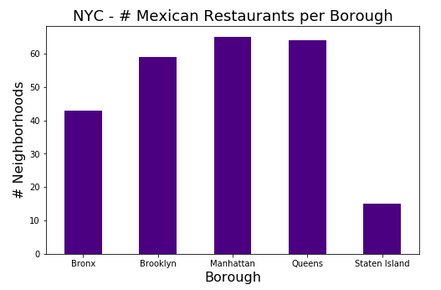

## Number of Mexican restaurants in each NYC neighborhood (top 10 here). Elmhurst and Jackson Heights have the most (each has 10).

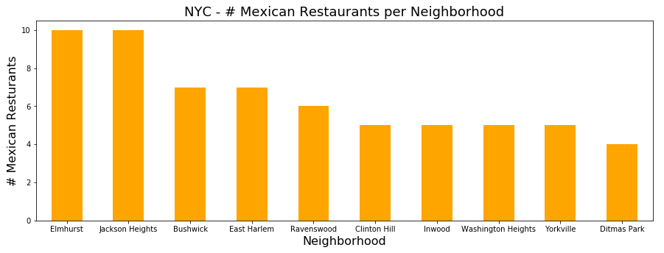

#### Here are the ten restaurants for Elmhurst and Jackson Heights:

#### Elmhurst:

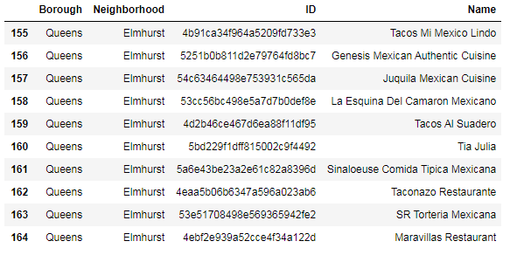

Jackson Heights:

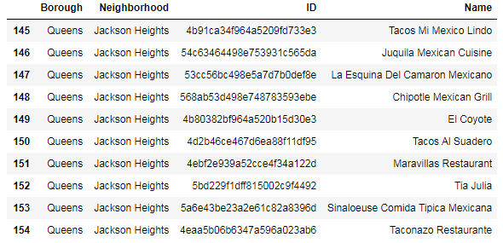

### Here are some statistics on the details (ratings, likes and tips) on all Mexican restaurants in NYC.

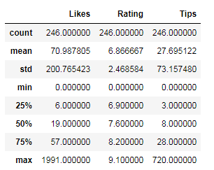

### Then a check was made to see which neighborhoods have the highest ratings.

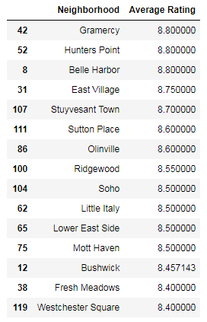

### A check to see which boroughs have the highest ratings.

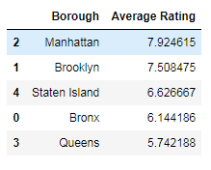

### These can be visualized as such:

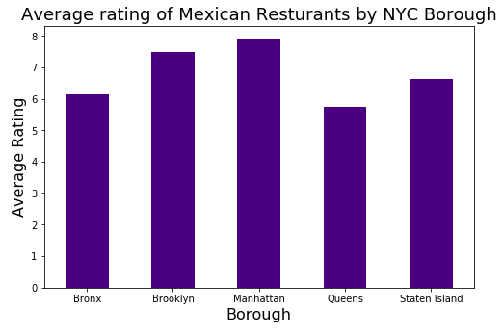

#### Here are the top 10 averages for the neighborhood ratings.

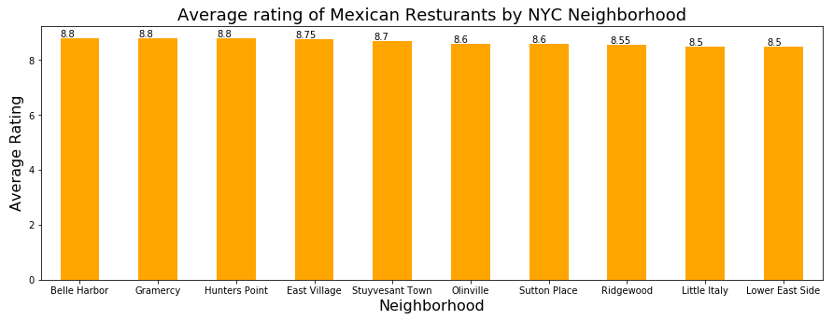

### What individual restaurant has the highest ratings?

Borough Queens

Neighborhood Ridgewood

Name Taquerias Kermes

Likes 50

Rating 9.1

Tips 28

### And the one with the most likes?

Borough Manhattan

Neighborhood Little Italy

Name La Esquina

Likes 1991

Rating 8.5

Tips 720

Below are the neighborhoods in NYC that have average Mexican restaurant ratings of 8.0 and above.

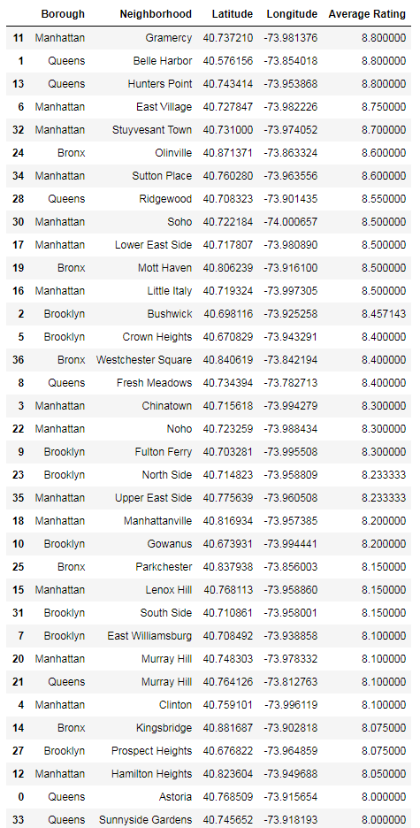

## Final Results!

### Borough: We have Manhattan as the Borough with the highest average rating (7.92).

### Neighborhood: We have Belle Harbor (in Queens), Grammercy (in Manhattan), and Hunter's Point (in Queens) tied as the Neighborhoods with the highest average rating (8.8).

### Restaurant: We have Taquerias Kermes as the Restaurant with the highest rating (9.1). Borough: Queens, Neighborhood: Ridgewood

### Restaurant: We have La Esquina as the Restaurant with the most likes (1,991). Borough: Manhattan, Neighborhood: Little Italy

Below is the data and a geographical plot of these 8.0+ rated Mexican restaurants in NYC.



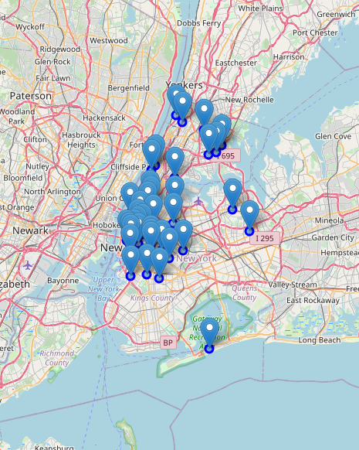

### Discussion¶

I would recommend Manhattan as the best borough for Mexican food in New York City. Manhattan has the least number of neighborhoods, but the most Mexican restaurants. Queens has the second most restaurants, and Queens has some of the top-rated restaurants, however Queens has an average rating of only 5.7, while Manhattan has an overall rating of 7.9. Brooklyn has the third most Mexican restaurants, and has an average rating of 7.5, so I would recommend Brooklyn as the second best borough after Manhattan for Mexican restaurants.

If I were to open a new Mexican restaurant in New York City, I'd choose the neighborhood Gramercy in Manhattan. It has the highest average rating for Mexican restaurants, so there's a demand there and people are used to going there for great Mexican food. With that sort of draw, I believe people would give new Mexican restaurant a chance there!

### Conclusion

With the Data Science methodology and tools we've learned in this course, it was fairly straightforward to process a whole lot of data and to come up with these statistics and recommendations regarding Mexican restaurants in New York City. I'm happy to have learned this material and am looking forward to using these tools and methodology in the future for all sorts of things!